**C1 Lab**

* I found 7 GET Http protocols.

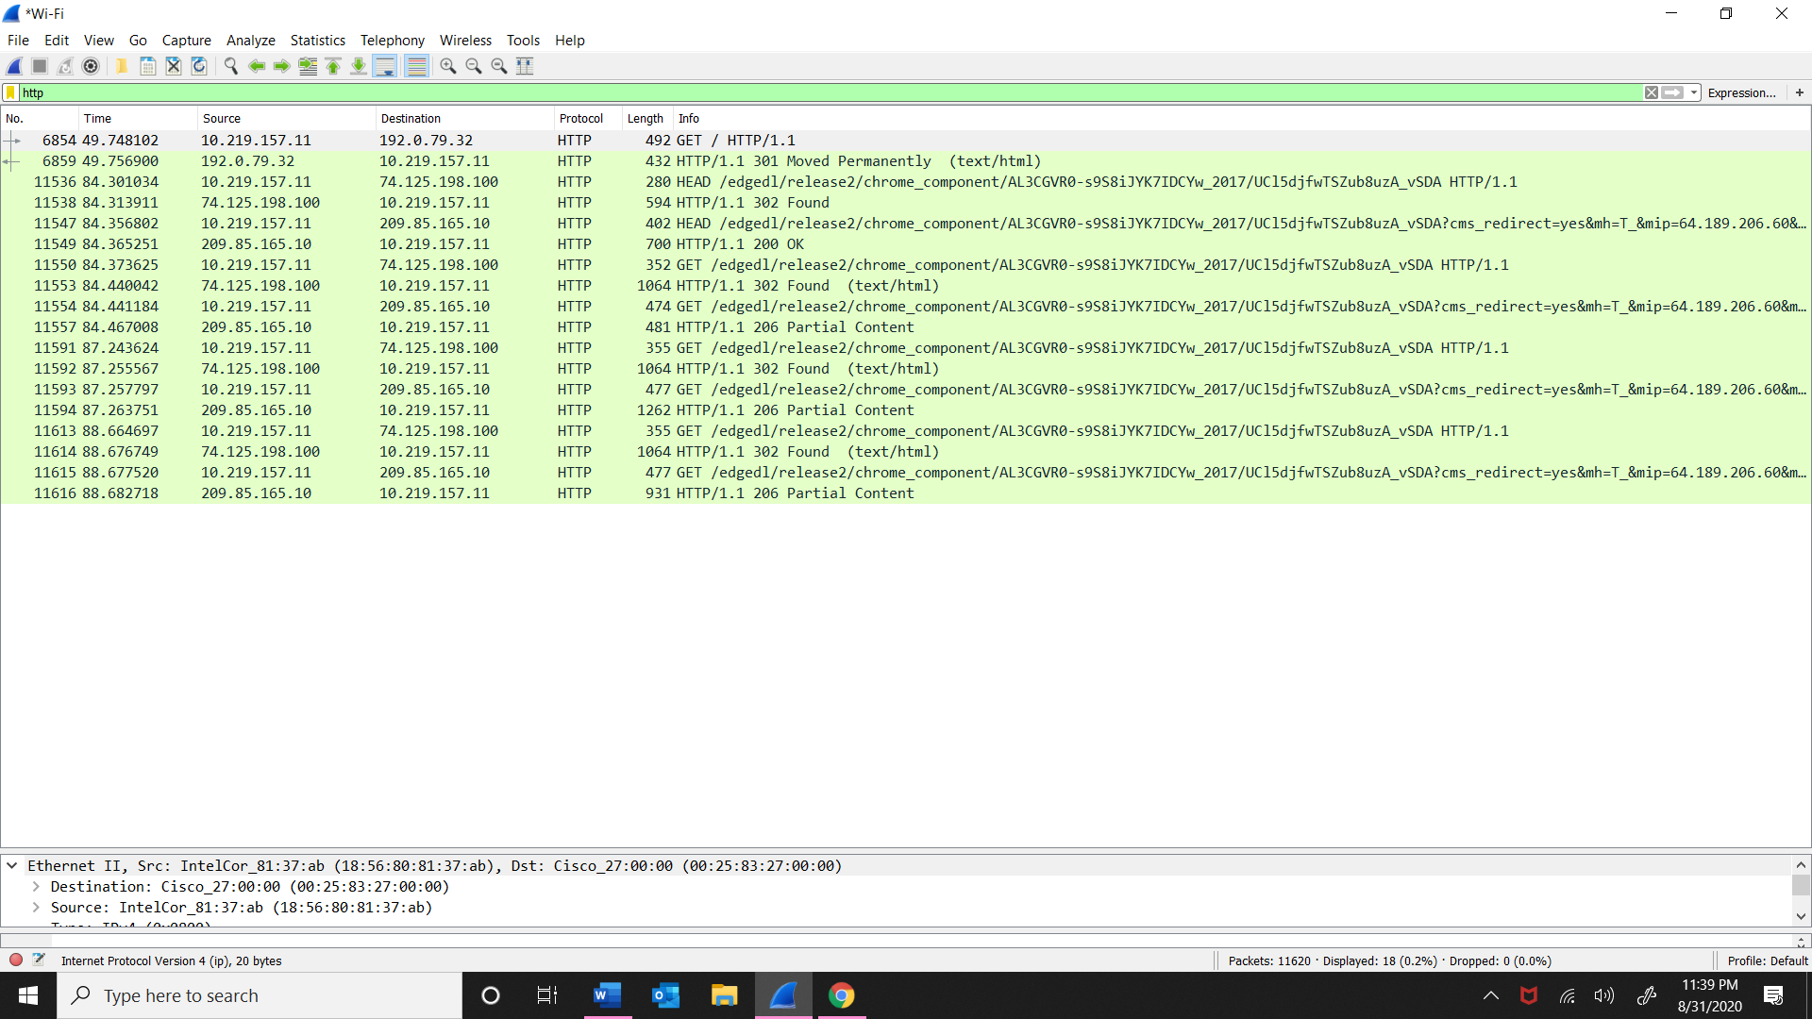

* This is the PDU at 2 (Ethernet Frame), 3 (IP packets) and 4 (TCP segment) layers.

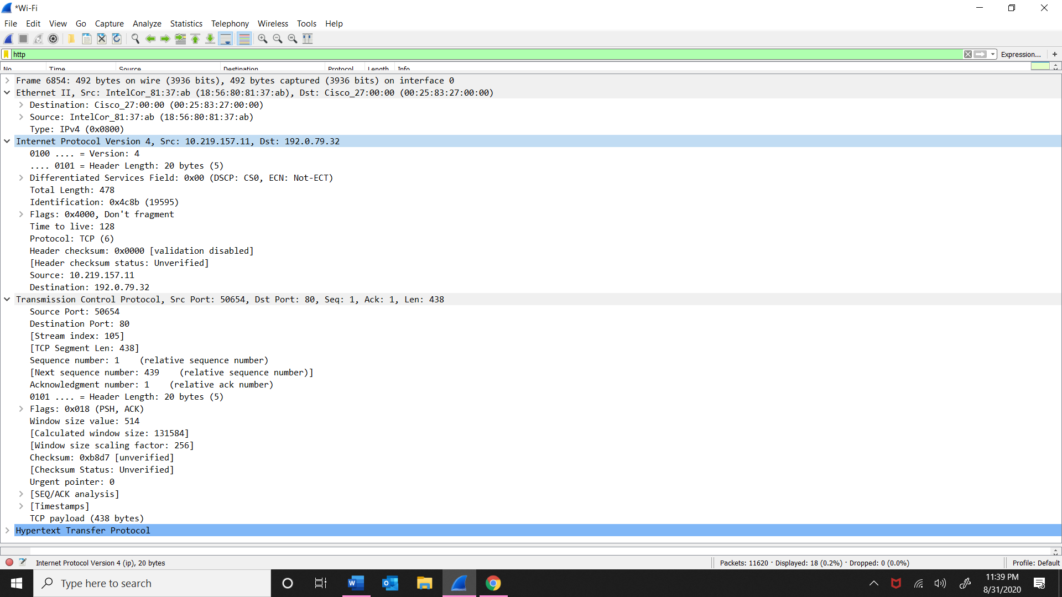

* These are the variety of protocols I found other than http.

